Roza Jiang
Sales Engineer at GitHub doing forward-deployed work with enterprise customers
Open to founding and enterprise Forward Deployed Engineer roles · GitHub Copilot · Agentic SDLC
Sydney, NSW, Australia · linkedin.com/in/rozaj · github.com/rozajay · linktr.ee/rozaj
SUMMARY
A full-stack engineer by background, I work with the hands-on engineers at enterprise customers across APAC in financial services and technology: surveying them, finding the real business problem, then building tailored GitHub Copilot workshops and prototypes around it and framing proofs of concept with account executives. Eight years of engineering and customer-facing delivery behind it, from conversational platforms for large Australian enterprises (NAB, Telstra, AustralianSuper) to technical discovery at Datadog, where I was 2024 APAC Rookie of the Year. Zero-to-one builds: a public workshop pack, a Copilot AI-credit usage extension and a daily-rebuilt GitHub Changelog archive. I also post on LinkedIn regularly: customised carousels of new GitHub features, all on my profile. I would rather show a working implementation than assert a conclusion.
EXPERIENCE
GitHub | Sales Engineer Feb 2026 – Present
Sydney, NSW (Remote)
- Discovery and baseline: survey each customer's hands-on engineers before an engagement to surface their real business problems, then shape workshop content, demos and prototypes around the answers.
- Hands-on delivery: build and run customised Copilot workshops around the customer's own problems, including an ~85-minute Vibe Coding workshop for a non-technical data team: build and publish a site, learn MCP (Model Context Protocol), create an Azure DevOps work item from the Copilot App, then take a homework task away.
- Enterprise AI sessions: lead sessions on the agentic SDLC (AI agents across software delivery): enterprise trust, pull-request throughput, token-use strategy and the GitHub roadmap for financial services and technology customers, including Chinese-language decks.
- Proofs of concept: work alongside account executives to frame the objectives and success criteria, Copilot workflow and expected impact, scope and next steps.
- Cost and governance: teach the controls enterprises need as adoption grows, including budget controls, token optimisation and customising Copilot code review.
- Reusable playbooks: maintain a library of 55 demos, workshops, guides and carousels (32 published, 23 customer-specific) and a public six-part Copilot workshop pack (linktr.ee/rozaj), so each engagement starts further along.
Datadog | Sales Engineer (SE 1, then SE 2 from Mar 2025) Sep 2023 – Dec 2025
Cloud monitoring and security platform · Sydney, NSW (Hybrid)
- Awarded 2024 APAC Rookie of the Year and Top Dog APJ (Asia Pacific and Japan; Q2 and Q3 2024).
- Spoke at apidays Australia 2025 (API and AI conference, Melbourne, 29–30 October 2025) on how LLM-as-a-judge evaluation works: one AI model grading another's answers.
- Customer-obsessed technical discovery: gathered requirements in detail to scope and run in-depth product evaluations, contributing to high-impact wins across ANZ.
Linktree | Full-Stack Engineer Jun 2021 – Jun 2023
Link-in-bio platform for creators and businesses · Melbourne, VIC
- Worked on the analytics team for Linktree's paid-tier analytics product, translating customer requirements into shipped features across backend and frontend.
- Built REST and GraphQL endpoints (TypeScript, PHP Symfony, AWS serverless) powering front-end analytics features in React; tested with Jest, CI on Buildkite.
Experios | Software Developer (part-time) Nov 2020 – Nov 2021
Melbourne, VIC
EstimateOne | Full-Stack Developer Dec 2020 – Jun 2021
Australia's online construction platform · Melbourne, VIC
- Full-stack developer on Foresite, a greenfield project: worked with the project manager and designers to deliver new front-end and back-end features (React, TypeScript, GraphQL, PHP Symfony, Jest).
Servian | IT Consultant Jul 2019 – Dec 2020
Technology consultancy · Melbourne, VIC
- NAB (a major Australian bank), Mar – Dec 2020: migrated a legacy Java service to Node.js so its virtual assistant could block a card and find the nearest ATM; improved the LiveChat widget (Node.js, React, TypeScript).
- AustralianSuper (Australia's largest super fund), Oct 2019 – Mar 2020: designed, built and launched a chatbot, bringing order to an unstructured, multi-stakeholder environment (Google Dialogflow, BigQuery).
- University of Melbourne (Jul – Oct 2019): built and launched a research commercialisation website (Vue, Nuxt).
Telstra | Graduate Front-End Developer Jan 2018 – Jul 2019
Australia's largest telecommunications company · Melbourne, VIC
- Internal Virtual Assistance team: built front-end features for Telstra Live Chat, a customised chat window connecting customers with live agents via Liveperson, alongside UX designers and testers.
- Delivered UI features for an internal SaaS product that content creators use to author conversation flows for Telstra's virtual assistant, Codi (React, Redux, TypeScript, AWS, Docker, Postgres).
SELECTED WORK
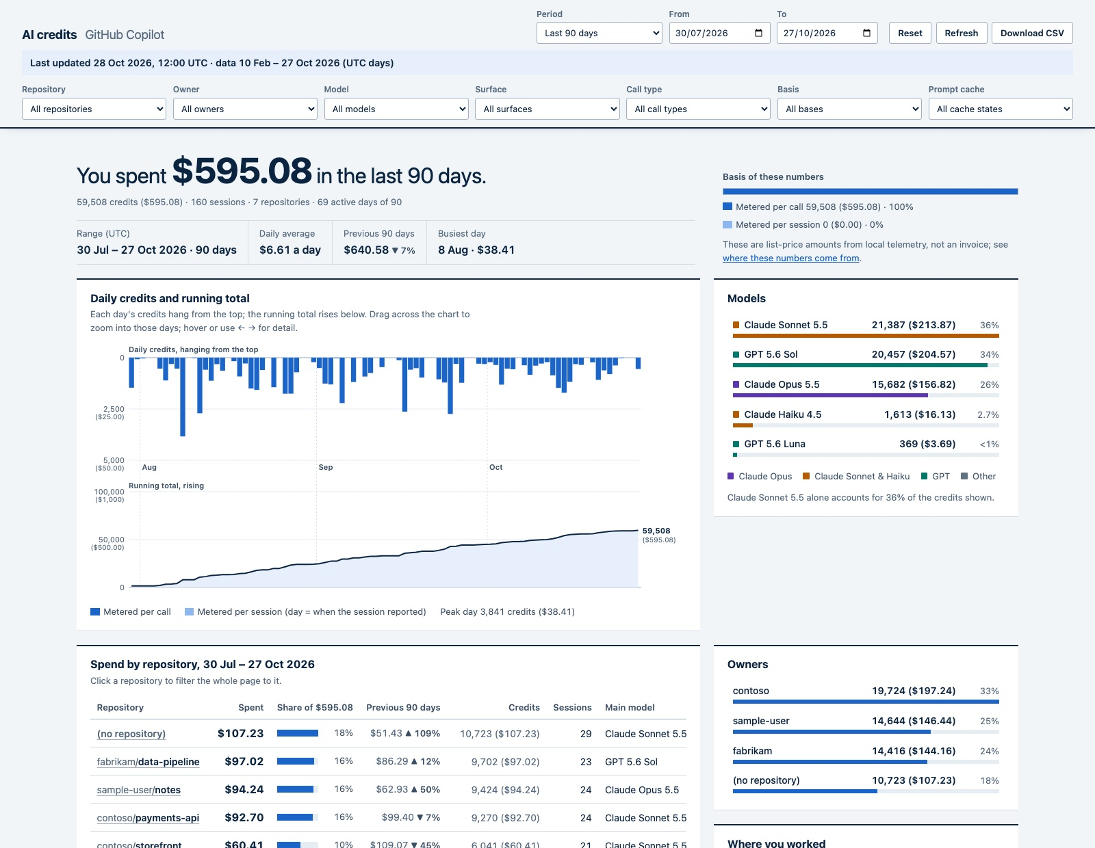 | AI Credits Breakdown  awesome-copilot.github.com/extension/ai-credits-breakdown  A private, detailed view of your own GitHub Copilot AI credit usage across every repository, organisation and Copilot surface: Period, repository, model and surface filters with CSV export · Daily credits chart with pace to month end · Prompt-cache breakdown showing what is reused versus rebuilt · Heaviest sessions and spend by automation.

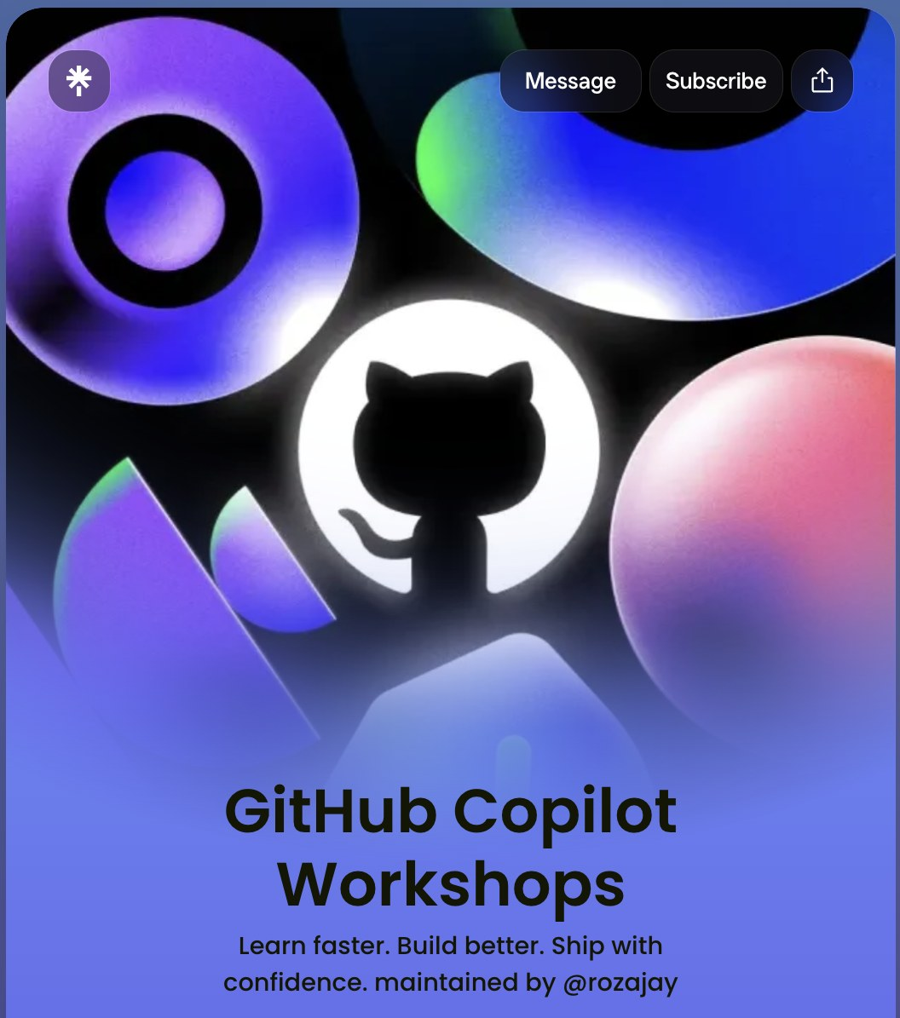 | GitHub Copilot Workshops (public pack)  linktr.ee/rozaj  Six self-serve workshops: Setting up Budget Control · Token Optimisation 101 · Rapid Prototyping with the GitHub Copilot App · 6 Ways to Customise Your Code Review · Top 10 GitHub Copilot Commands · Get Started with GitHub Copilot in VS Code.

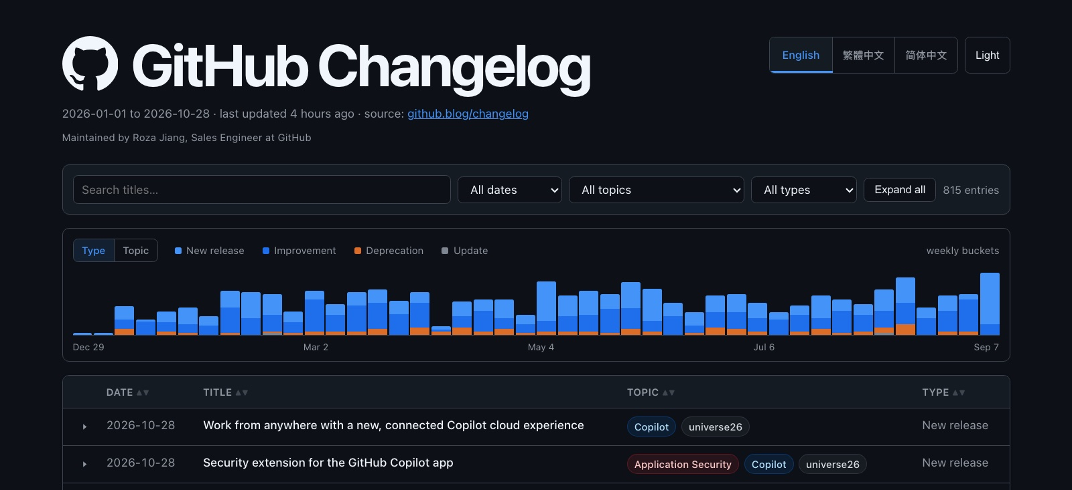 | GitHub Changelog archive  rozajay.github.io/GitHub-Changelog  Every GitHub Changelog entry since January 2026, rebuilt daily by GitHub Actions: AI-written TL;DRs in English, Traditional and Simplified Chinese · An activity chart that doubles as a date picker · A LinkedIn carousel for each new entry, scripted by Copilot CLI and validated before rendering.

EDUCATION
Master of Engineering (Electronics) · University of Melbourne 2016 – 2017
Bachelor of Science (Electrical Systems) · University of Melbourne 2012 – 2014
CERTIFICATIONS
- AWS Certified Developer – Associate
- GitHub Administration
- GitHub Copilot
- Toastmasters International, Level 1
LANGUAGES
English · Chinese
SKILLS
Enterprise customer delivery: Technical discovery and survey design, workshop design and delivery, proof-of-concept framing, requirements gathering, developer enablement
AI-assisted development: GitHub Copilot (Copilot App, code review), MCP (Model Context Protocol), agentic SDLC (AI agents across software delivery), token and budget governance
GitHub platform: GitHub Enterprise administration, billing and budgets, Azure DevOps integration
Engineering: TypeScript, JavaScript, React, Redux, Node.js, GraphQL, REST, PHP (Symfony), Vue/Nuxt, Jest
Cloud and tooling: AWS (serverless), Docker, Postgres, Google Dialogflow and BigQuery, Buildkite, Sentry, Jira, Confluence

